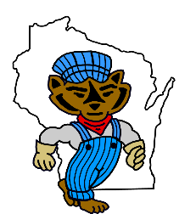
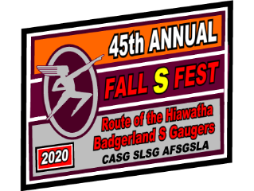

The Badgerland S Gaugers wish to apologize for the inconvenience caused by the delay in the delivery of the 2016 Fall S Fest, Wood Sided, Sprecher, Root Beer, Reefer Cars. This unfortunate incident was out of our control. Fortunately, when delivered, the cars were beautifully crafted. Thanks to all of you, who ordered those cars, for your patience.

BSG has the complete order of the 45th Annual Commemorative Fall S Fest Hopper cars.
They have been in stock since “December of 2019”.
