2025 FALL S FEST

COMMEMORATIVE CAR SALE
$60.00 EACH Hi-Rail only
NAME:
ADDRESS:
PHONE NO:
EMAIL:

Car #4851 with a Black Roof and Ends

( ) Hi-Rail | 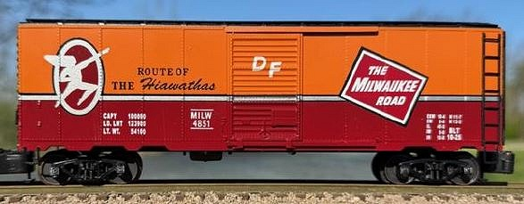

IF SHIPPED: $10.00 PER CAR $3.00 EACH ADDITIONAL CAR
TOTAL: | $
For Additional Information Contact:
Tom Patterson Email: tpatterson31@wi.rr.com

